St. Michael's Episcopal Church

A Christ-Centered Community of Practice Awakening to the Abiding Presence of God

The Third Sunday in Lent, 15 March, 2020

WE GATHER IN THE NAME OF CHRIST

welcome & announcements
After the Announcements, a period of silence is kept. Please stand when you hear the bell.
SILENT PROCESSION

ACCLAMATION

Blessed be the God of our salvation:
Who bears our burdens and forgives our sins.

The Celebrant says:
Jesus said, “The first commandment is this: Hear, O Israel: The Lord our God is the only Lord. Love the Lord your God with all your heart, with all your soul, with all your mind, and with all your strength. The second is this: Love your neighbor as yourself. There is no other commandment greater than these.” Mark 12:29-31

LITANY OF PENITENCE

The Celebrant and People together, kneeling or standing, if able.

Most holy and merciful Father:
We confess to you and to one another,
and to the whole communion of saints
in heaven and on earth,
that we have sinned by our own fault
in thought, word, and deed;
by what we have done, and by what we have left undone.

We have not loved you with our whole heart, and mind, and strength. We have not loved our neighbors as ourselves. We have not forgiven others, as we have been forgiven.
Celebrant: Have mercy on us, Lord.

We have been deaf to your call to serve, as Christ served us. We have not been true to the mind of Christ. We have grieved your Holy Spirit.
Have mercy on us, Lord.

We confess to you, Lord, all our past unfaithfulness: the pride, hypocrisy,
and impatience of our lives,
We confess to you, Lord.

Our self-indulgent appetites and ways, and our exploitation of other people,
We confess to you, Lord.

Our anger at our own frustration, and our envy of those more fortunate than ourselves,
We confess to you, Lord.

Our intemperate love of worldly goods and comforts, and our dishonesty in daily life and work,
We confess to you, Lord.

Our negligence in prayer and worship, and our failure to commend the faith that is in us,
We confess to you, Lord.

Accept our repentance, Lord, for the wrongs we have done: for our blindness to human need and suffering, and our indifference to injustice and cruelty,
Accept our repentance, Lord.

For all false judgments, for uncharitable thoughts toward our neighbors, and for our prejudice and contempt toward those who differ from us,
Accept our repentance, Lord.

For our waste and pollution of your creation, and our lack of concern for those who come after us,
Accept our repentance, Lord.

Accomplish in us the work of your salvation,
That we may show forth your glory in the world.
By the cross and passion of your Son our Lord,
Bring us with all your saints to the joy of his resurrection.
May the Father of all mercy forgive you, draw you forth into life and peace, and make real the hope that we, and all creation, be released from bondage and obtain the freedom of the glory of the children of God, through Jesus Christ, our Lord. Amen.

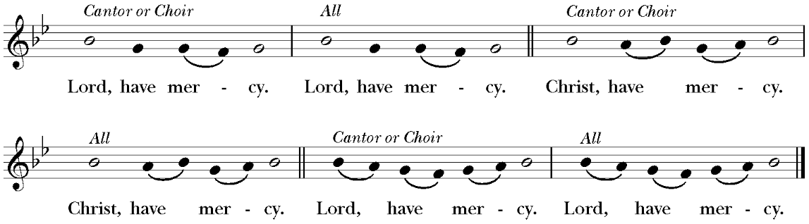

COLLECT OF THE DAY
The Lord be with you.
And also with you.
Let us pray.
Almighty God, you know that we have no power in ourselves to help ourselves: Keep us both outwardly in our bodies and inwardly in our souls, that we may be defended from all adversities which may happen to the body, and from all evil thoughts which may assault and hurt the soul; through Jesus Christ our Lord, who lives and reigns with you and the Holy Spirit, one God, for ever and ever. Amen.

WE PROCLAIM AND RESPOND TO THE WORD OF GOD

the first reading Exodus 17: 1-7 The people are at the point of rebellion because they are without water in the wilderness.

Following the Lesson...
Hear what the Spirit is saying to God’s people
Thanks be to God.

psalm 95
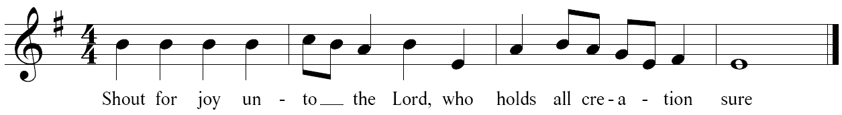
1 Come, let us sing to the Lord; *
let us shout for joy to the Rock of our salvation.
2 Let us come before his presence with thanksgiving *
and raise a loud shout to him with psalms.
RESPONSE
3 For the Lord is a great God, *
and a great King above all gods.
4 In his hand are the caverns of the earth, *
and the heights of the hills are his also.
RESPONSE
5 The sea is his, for he made it, *
and his hands have molded the dry land.
6 Come, let us bow down, and bend the knee, *
and kneel before the Lord our Maker.
7 For he is our God,
and we are the people of his pasture and the sheep of his hand. *
Oh, that today you would hearken to his voice!
RESPONSE

the epistle Romans 5: 1- 11 Paul bids disciples to rejoice in the reconciliation and hope which are theirs because of the sacrifice of Christ on behalf of sinners.

Following the Lesson...
Hear what the Spirit is saying to God’s people
Thanks be to God.

hymn The Hymnal 685

Preceding the Gospel...
The Holy Gospel of our Lord Jesus Christ according to John
Glory to you, Lord Christ.

the holy gospel John 4: 5-42 The story of Jesus’ meeting with the Samaritan woman by Jacob’s well.
Following the Gospel...
The Gospel of the Lord.
Praise to you, Lord Christ.
sermon The Reverend Jean Smith

After the sermon a period of silence is kept.

the prayers of the people

Prayers are offered for the world, the church, the sick, etc. followed by a period of silence. Congregation members are invited to offer intercessions during the silence, either aloud or silently.

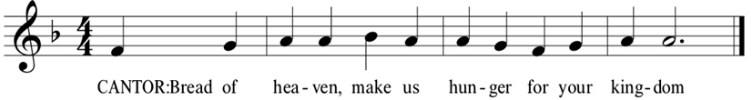

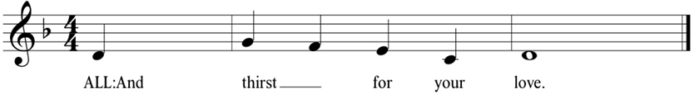

the peace
The peace of the Lord be always with you.
And also with you.

Please stay in your seats and offer “peace” through smiles or bowing.

We share holy communion together

ANTHEM

All stand to sing
the offertory hymn The Hymnal 309

the offering

During this time of being extra careful about germs, we ask you to bring your offering forward when you come for Communion and put them in the offering plates in the front of the church.

Our ministry at St. Michael’s depends on your generosity. Please consider making a donation or a pledge.

the great thanksgiving
The Lord be with you.
And also with you.
Lift up your hearts.
We lift them to the Lord.
Let us give thanks to the Lord our God.
It is right to give him thanks and praise.
The Presider praises God for God’s creation and love. Then all sing the Sanctus together, first is Spanish and then in English:

The People remain standing, if able.

The Presider recalls and makes present for all Jesus’ life and last supper.

The Presider recalls and makes present for all Jesus’ life and last supper.

The Presider asks the Holy Spirit to consecrate the bread and the wine to be God’s holy food.

And now, as our Savior Christ has taught us, we are bold to say,

People and Celebrant

Our Father, who art in heaven, hallowed be thy Name, thy kingdom come, thy will be done, on earth as it is in heaven. Give us this day our daily bread. And forgive us our trespasses, As we forgive those who trespass against us. And lead us not into temptation, but deliver us from evil. For thine is the kingdom, and the power, and the glory, for ever and ever. Amen.

Bread is Broken

The Celebrant breaks the consecrated Bread.
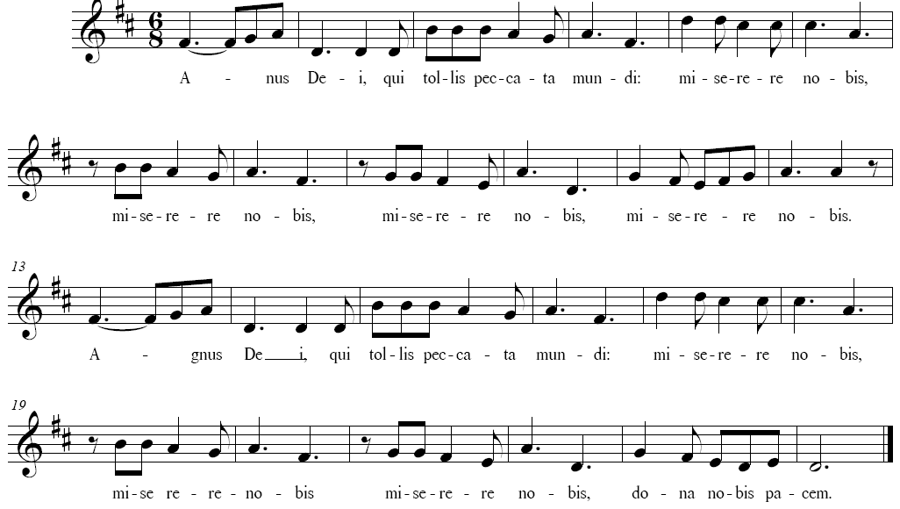

Translation: “Lamb of God, who takes away the sin of the world, have mercy on us, grant us peace.”

Facing the people, the Celebrant says the following Invitation

The Gifts of God for the People of God.

Bread and Wine are Shared

Invitation to Receive the Sacrament of Holy Communion

At St. Michael's, we believe that God's love is unconditional. We welcome all people and we affirm the worth, dignity, and gifts of every person as a beloved child of God. In our celebration of the Eucharist, there is no one here who is ineligible or unwelcome; no one who has too many doubts or too few beliefs. This is the table of a loving God set for all creation through the power of Jesus Christ. You, who are part of that creation, are welcome.

Gluten-free wafers are available. If you would like a gluten-free wafer, please indicate that preference to the liturgical minister.
During this time we will distribute the bread only. Or if you wish to come to the Altar for a blessing only, please fold your arms over your chest.

Following Communion, the congregation stands to say the final prayer:
postcommunion prayer

Eternal God, heavenly Father,
you have graciously accepted us as living members
of your Son our Savior Jesus Christ,
and you have fed us with spiritual food
in the Sacrament of his Body and Blood.
Send us now into the world in peace,
and grant us strength and courage
to love and serve you
with gladness and singleness of heart;
through Christ our Lord. Amen.

We Are Sent and Go Forth
into the World

lenten prayer

hymn in procession The Hymnal 699

dismissal

Participants Today

8:00: Dan Houder, lay assistant; Doug Switzer, intercessor; Jake Morrow, usher; Janet Cramer, sacramental healing. 10:15: Mikael Mattson, crucifer; Jake Mattson and KC Mattson, torchbearers; Sarah & John Gagnon, ushers; Miranda Smith, lay assistant; Jenny Karstad, lector; Imogene Drakes, intercessor; Daniel Dobson and Dick Burtis, element bearers; Robin White and Judith Junkins, sacramental healing; Craig Newbert, Irene Burtis, Laurie Chiperfield and Marisa Birri, Altar Guild; Ricky Davidson and Jared Rediske, counters; John & Julie Laamanen, coffee hour.

At St. Michael’s we believe that God’s love is unconditional. We welcome all people and we affirm the worth, dignity, and gifts of every person as a beloved child of God.
All are welcome to receive the sacrament of Holy Communion.
      - WELCOME TO VISITORS! All are welcome at this table. If you have any questions about the liturgy, location of the bathrooms, or anything else, please ask one of the ushers or greeters. Thank you for joining us today.
- TO RECEIVE THE RITE OF HEALING: Healing prayers will be suspended at this time. If you would like someone to call you and say a prayer with you, please sign up in the Common Room, email Jeanie at Jeanie@stmichaelsvermont.org or call the church office at 802 254-6048.
- GLUTEN FREE WAFERS are available for Communion at both 8:00am and 10: 15 services. Please make yourselves known to the priest when you come up for Communion.
- CHILDREN ARE WELCOME HERE! Godly Play Sunday School is available for children ages 3-11 for the first half of the service. Please ask ushers to show you to the Godly Play Room. Children are also welcome to stay in the sanctuary for the service. There are clipboards with paper and crayons, as well as activity bags with coloring books at the back of the Sanctuary for children who are interested in coloring or drawing during the service. Feel free to come in and out of the worship area as needed with your children! Please ask an usher if you need assistance.

WEEKDAY WORSHIP IN THE CHAPEL
Silent Meditation, 6-7 am, Monday-Friday
Morning Prayer, 8-8:30 am, Monday-Friday
Holy Eucharist, 12-12:30 pm, Wednesday
Contemplative Worship, 5:30-6:00 pm, Thursday
Centering Prayer, 8-9 am, Saturday

ANNOUNCEMENTS

HAPPY BIRTHDAY to Benson Bobrick and Jeff Hiam, Today; Chris Chapman, Monday; Karen Guthrie, Thursday; Bob Walker, Friday.

THIS MORNING, we will celebrate Holy Communion with bread and will not share a common cup. We will pass the peace without moving about or touching and will collect offerings in the front of the church before the altar, rather than passing the plate. Thank you for being flexible as we try to balance our need to be grounded in our faith while exercising an abundance of caution for the most vulnerable in our community.
GODLY PLAY TODAY: Families are encouraged to talk with their children about the stories and to contact the leaders with any questions. The story today is about Jesus and Zaccheus, the story teller is Josh Fritz, and the doorkeeper is Christy Fritz.
LENTEN SERIES CONTINUES THIS TUESDAY, MARCH 17: Please check the website to see if this program is still happening before attending. There will be a simple supper in the Undercroft from 5:15 to 6 pm. The program will be in the Meeting Room from 6-7 pm. This Tuesday in the program on Reconciliation & 12-Step Spirituality, Jeff H. talks about the questions “What is the story behind the 12-Step movement?” and “Why is Step 9 (making amends) so important?” The program is followed by Night Prayer from 7 – 7:15 pm. All are welcome for any part or all of the evening.
HELP NEEDED FOR THE LENTEN SUPPERS: At 5:15 p.m. on Tuesdays during Lent, we will gather for a community supper before the Lenten program. This year we will again have soup and homemade bread. We hope to also serve pizza and salad. We need help to make this happen! Please sign up in the Common Room if you can:
- Make a pot of soup (2-3 people to bring pots of soup to share)
- Make a salad
- Bring 2 large cheese pizzas
- Help set up at 5:00 p.m. (set tables and set out food)
- Help Clean up (clean up food and dishes)
THE WEDNESDAY EVENING DISCIPLESHIP GROUP MEETS THIS WEEK ON MARCH 18: This discipleship group is inviting new members from now until June 17, after which we will close in order to cultivate depth and closeness. We meet together on the first and third Wednesdays of the month from 5:30 to 7:00 for Evening Prayer, food, fellowship, and discussion. At 7:30, we return to the chapel for Compline, a sung form of night prayer, to which all are welcome. If you have yet to participate in a discipleship group, are looking for a small group with which to share your spiritual life, or are curious about what we are doing, please join us! We hope to see you there!

MARCH 22 ADULT FORUM: Janet Cramer and Linda Rice will lead this Forum on “Aging.” The space between being completely independent and being ready for death for some is short, but for many of us it is longer than it used to be. There are some questions to ask — and to answer in advance as much as possible. What are your questions? Please bring them and the solutions you
have come to.

OUR SECOND “SACRED GROUND” GROUP AT ST. MICHAEL’S: This program will be postponed.

TAG SALE TIDBITS: SORTING VOLUNTEERS URGENTLY NEEDED -- Come join us for 2 hours of fellowship. At the same time, discover the value of other people’s donations. You may even find something that attracts your eye and becomes a must have. Every Monday, 2 – 4 PM and Tuesday, 2 - 4 PM. Additional special one-time of Wednesday, March 18, 9 – 11AM. Questions? Email or call Sherry Stimmel at sherrys@iglide.net or 802-254-8470. Thank you.

COMMUNITY ANNOUNCEMENT

FAURE’S REQUIEM , MARCH 26 has been canceled in the interest of virus containment.

