Table of Contents
Table of Contents 1
Daily Morning Prayer: Rite Two p75BCP 4
The Officiant begins the service with one or more of these sentences of Scripture, or with the versicle "Lord, open our lips" on page 80BCP. 4
Opening Sentences 4
Advent 4
Christmas 4
Lent 4
Easter Season, including Ascension Day and the Day of Pentecost 5
Trinity Sunday 5
All Saints and other Major Saints' Days 5
Occasions of Thanksgiving 5
At any Time 5
Confession of Sin 6
The Invitatory and Psalter p80 6
Invitatory Antiphons 7
In Advent 7
From the Epiphany through the Baptism of Christ, and on the Feasts of the Transfiguration and Holy Cross 7
From Ascension Day until the Day of Pentecost 7
On the Day of Pentecost 7
On Trinity Sunday 7
On other Sundays and weekdays 7
On Feasts of the Incarnation 8
On All Saints and other Major Saints' Days 8
Venite 8
Jubilate 9
Christ our Passover 10
Psalm 63:1-8 12
Psalm 67:1-5 12
The Daily Psalter 13
The Lessons and Canticles 13
Canticles from the BCP (Are sung or said by all after each Reading. p47-53 & 85-96, and EOW) 13
8 The Song of Moses 13
9 The First Song of Isaiah 14
10 The Second Song of Isaiah 16
11 The Third Song of Isaiah 17
12 A Song of Creation 18
13 A Song of Praise 20
14 A Song of Penitence 21
15 The Song of Mary 23
16 The Song of Zechariah 25
18 A Song to the Lamb 26
19 The Song of the Redeemed 27
20 Glory to God 29
21 You are God 29
Canticles from Enriching Our Worship 30
B - A Song of Pilgrimage 30
Canticle D - A Song of the Wilderness 30
Canticle E - A Song of Jerusalem Our Mother 31
Canticle F - A Song of Lamentation 31
Canticle G - A Song of Ezekiel 32
Canticle J - A Song of Judith 32
Canticle L - A Song of Christ’s Humility 33
Canticle M - A Song of Faith 33
Canticle N - A Song of God’s Love 33
Canticle Q – A Song of Christ’s Goodness 34
The Apostles' Creed 34
The Prayers 35
Standing or Kneeling p97BCP 35
Suffrages 36
Suffrages A 36
Suffrages B 38
Suffrages C 39
The Collects 39
I. The Collect of the Day 39
II. A second Collect from below 39
III. Collects for Mission 40
Concluding Prayers 41
The General Thanksgiving 41
An Alternate Thanksgiving 41
A Prayer of St. Chrysostom 42
Concluding Versicle and Response 42
Dismissal 43

Daily Morning Prayer: Rite Two p75BCP

The Officiant begins the service with one or more of these sentences of
Scripture, or with the versicle "Lord, open our lips" on page 80BCP.

Opening Sentences
All Standing
Advent
Watch, for you know not when the master of the house will come, in the evening, or at midnight, or at cockcrow, or in the morning; lest he come suddenly and find you asleep. Mark 13:35, 36

In the wilderness prepare the way of the Lord, make straight in the desert a highway for our God. Isaiah 40:3

The glory of the Lord shall be revealed, and all flesh shall see it together. Isaiah 40:5
Christmas
Behold, I bring you good news of a great joy, which will come to all the people; for unto you is born this day in the city of David, a Savior, who is Christ the Lord. Luke 2:10, 11

Behold, the dwelling of God is with mankind. He will dwell with them, and they shall be his people, and God himself will be with them, and be their God. Revelation 21:3
Epiphany
Nations shall come to your light, and kings to the brightness of your rising. Isaiah 60:3

I will give you as a light to the nations, that my salvation may reach to the end of the earth. Isaiah 49:6b

From the rising of the sun to its setting my Name shall be great among the nations, and in every place incense shall be offered to my Name, and a pure offering: for my Name shall be great among the nations, says the Lord of hosts. Malachi 1:11

Lent
If we say we have no sin, we deceive ourselves, and the truth is not in us; but if we confess our sins, God who is faithful and just, will forgive our sins and cleanse us from all unrighteousness. I John 1:8, 9

Rend your hearts and not your garments. Return to the Lord your God, for he is gracious and merciful, slow to anger and abounding in steadfast love, and repents of evil. Joel 2:13

I will arise and go to my father, and I will say to him, "Father, I have sinned against heaven, and before you; I am no longer worthy to be called your son." Luke 15:18, 19

To the Lord our God belong mercy and forgiveness, because we have rebelled against him and have not obeyed the voice of the Lord our God by following his laws which he set before us. Daniel 9:9, 10

Jesus said, "If anyone will come after me, let him deny himself, and take up his cross, and follow me." Mark 8:34
Holy Week
All we like sheep have gone astray; we have turned everyone to his own way; and the Lord has laid on him the iniquity of us all. Isaiah53:6

Is it nothing to you, all you who pass by? Look and see if there is any sorrow like my sorrow which was brought upon me, whom the Lord hath afflicted. Lamentations 1:12

Easter Season, including Ascension Day and the Day of Pentecost
Alleluia! Christ is risen. The Lord is risen indeed. Alleluia!

On this day the Lord has acted; we will rejoice and be glad in it. Psalm 118:24

Thanks be to God, who gives us the victory through our Lord Jesus Christ. 1 Corinthians 15:57

If then you have been raised with Christ, seek the things that are above, where Christ is, seated at the right hand of God. Colossians 3:1

Christ has entered, not into a sanctuary made with hands, a copy of the true one, but into heaven itself, now to appear in the presence of God on our behalf. Hebrews 9:24

You shall receive power when the Holy Ghost has come upon you; and you shall be my witness in Jerusalem, and in all Judea, and Samaria, and to the ends of the earth. Acts 1:8

Trinity Sunday
Holy, holy, holy is the Lord God Almighty, who was, and is, and is to come. Revelation 4:8

All Saints and other Major Saints' Days
We give thanks to the Father, who has made us worthy to share in the inheritance of the saints in light. Colossians 1:12

You are no longer strangers and sojourners, but fellow citizens with the saints and members of the household of God.
Ephesians 2:19

Their sound has gone out into all lands, and their message to the ends of the world. Psalm 19:4

Occasions of Thanksgiving
O give thanks to the Lord, and call upon his Name; make known his deeds among the peoples. Psalm 105:1

At any Time
Grace to you and peace from God our Father and from the Lord Jesus Christ. Philippians 1:2

I was glad when they said to me, "Let us go to the house of the Lord.” Psalm122:1

Let the words of my mouth and the meditation of my heart be acceptable in your sight, O Lord, my strength and my redeemer. Psalm 19:14

Send out your light and your truth, that they may lead me, and bring me to your holy hill and to your dwelling. Psalm 43:3

The Lord is in his holy temple; let all the earth keep silence before him. Hab 2:20

The hour is coming, and now is, when the true worshipers will worship the Father in spirit and in truth, for such the Father seeks to worship him. John 4:23

Thus says the high and lofty One who inhabits eternity, whose name is Holy, "I dwell in the high and holy place and also with the one who has a contrite and humble spirit, to revive the spirit of the humble and to revive the heart of the contrite."
Isaiah 57:15

The following Confession of Sin may then be said; or continue on p80BCP

Confession of Sin
p79BCP
The Officiant says: Dearly beloved, we have come together in the presence of Almighty God our heavenly Father, to set forth his praise, to hear his holy Word, and to ask, for ourselves and on behalf of others, those things that are necessary for our life and our salvation. And so that we may prepare ourselves in heart and mind to worship him, let us kneel in silence, and with penitent and obedient hearts confess our sins, that we may obtain forgiveness by his infinite goodness and mercy.
or this: Let us confess our sins against God and our neighbor. Silence may be kept.

Officiant and People together, all kneeling or bowing as able
Most merciful God, we confess that we have sinned against you
in thought, word, and deed, by what we have done,
and by what we have left undone.
We have not loved you with our whole heart;
we have not loved our neighbors as ourselves.
We are truly sorry and we humbly repent.
For the sake of your Son Jesus Christ,
have mercy on us and forgive us; that we may delight in your will,
and walk in your ways, to the glory of your Name. Amen.

The Priest may stand alone and says (A deacon, lay person, or priest using the preceding form remains kneeling, and substitutes "us" for "you" and "our" for "your.") p80BCP
Almighty God have mercy on you (us), forgive you(us) all (y)our sins through our Lord Jesus Christ, strengthen you (us) in all goodness, and by the power of the Holy Spirit keep you (us) in eternal life. Amen.

The Invitatory and Psalter p80
All Standing
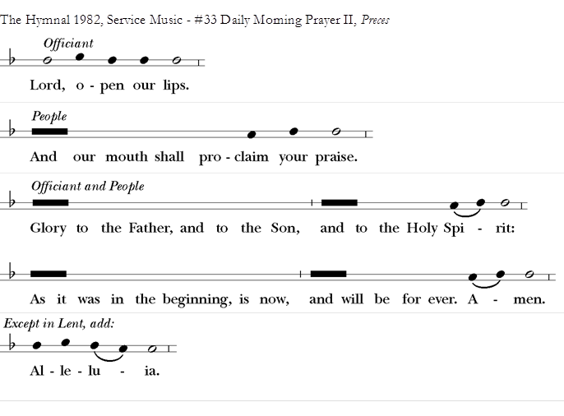
One of the following Antiphons may be sung or said with the
Invitatory Psalm, which calls our hearts to a spirit of adoration and worship

Invitatory Antiphons

In Advent
Our King and Savior now draws near: Come, let us adore him.
On the Twelve Days of Christmas
Alleluia. To us a child is born: O come, let us adore him. Alleluia.

From the Epiphany through the Baptism of Christ, and on the Feasts of the Transfiguration and Holy Cross
The Lord has shown forth his glory: Come let us adore him.
In Lent
The Lord is full of compassion and mercy: Come let us adore him.
From Easter Day until the Ascension
Alleluia. The Lord is risen indeed: Come let us adore him. Alleluia.

From Ascension Day until the Day of Pentecost
Alleluia. Christ the Lord has ascended into heaven: Come let us adore him. Alleluia.

On the Day of Pentecost
Alleluia. The Spirit of the Lord renews the face of the earth: Come let us adore him. Alleluia.

On Trinity Sunday
Father, Son, and Holy Spirit, one God: Come let us adore him.

On other Sundays and weekdays
The earth is the Lord's for he made it: Come let us adore him.
or this
Worship the Lord in the beauty of holiness: Come let us adore him.
or this
The mercy of the Lord is everlasting: Come let us adore him.
or this
Christ has triumphed over death: O come let us worship.
or this
God is the Rock of our salvation: O come let us worship.
or this
The Holy One is in our midst: O come let us worship.
The Alleluias in the following Antiphons are used only in Easter Season.

On Feasts of the Incarnation
[Alleluia.] The Word was made flesh and dwelt among us: Come, let us adore him. [Alleluia.]

On All Saints and other Major Saints' Days
On All Saints and other Major Saints’ Days The bracketed Alleluias in this Antiphon are used only in Easter Season.
[Alleluia.] The Lord is glorious in his saints: Come, let us adore him. [Alleluia.]
[Alleluia.] Our God is glorious in all the saints: O come let us worship. [Alleluia.]

Venite

p21EOW
Come, let us sing to the Lord; *
let us shout for joy to the Rock of our salvation.
Let us come before God’s presence with thanksgiving *
and raise to the Lord a shout with psalms.
For you are a great God; *
you are great above all gods.
In your hand are the caverns of the earth, *
and the heights of the hills are yours also.
The sea is yours, for you made it, *
and your hands have molded the dry land.
Come, let us bow down and bend the knee, *
and kneel before the Lord our Maker.
For you are our God, and we are the people of your pasture and the sheep of your hand. *
Oh, that today we would hearken to your voice!

Or chanted
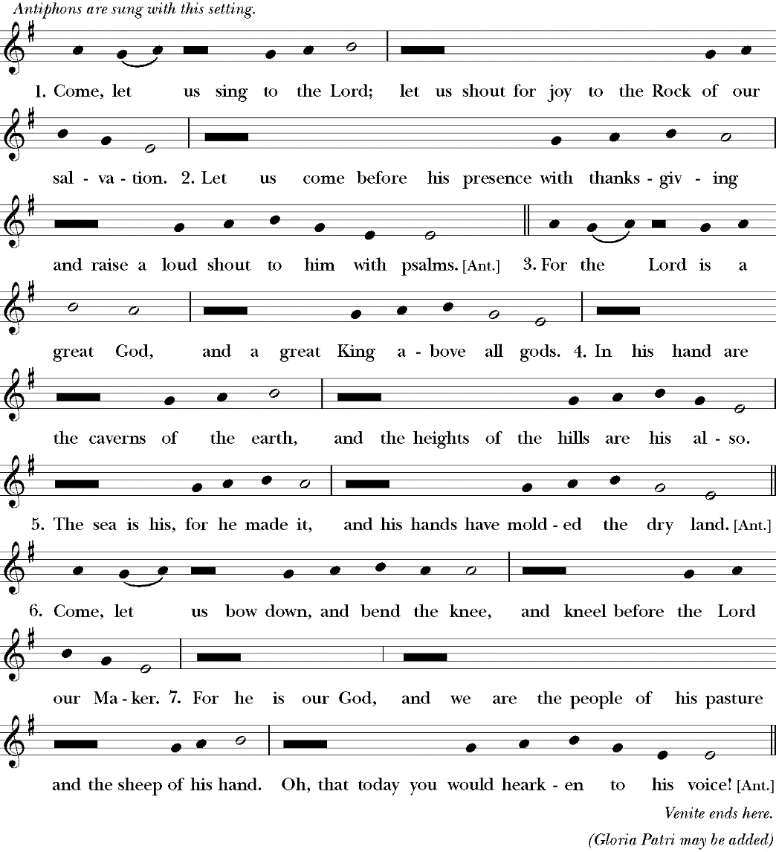

Jubilate
p82BCP
Be joyful in the Lord, all you lands; *
serve the Lord with gladness
and come before his presence with a song.
Know this: The Lord himself is God; *
he himself has made us, and we are his;
we are his people and the sheep of his pasture.
Enter his gates with thanksgiving;
go into his courts with praise; *
give thanks to him and call upon his Name.
For the Lord is good;
his mercy is everlasting; *
and his faithfulness endures from age to age.

Or chanted
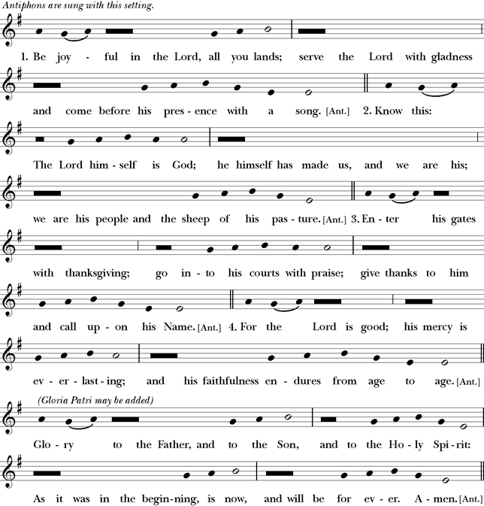
Christ our Passover
p83BCP Pascha nostrum 1 Corinthians 5:7-8; Romans 6:9-11; 1 Corinthians 15:20-22
Alleluia.
Christ our Passover has been sacrificed for us; *
therefore let us keep the feast,
Not with the old leaven, the leaven of malice and evil, *
but with the unleavened bread of sincerity and truth. Alleluia.
Christ being raised from the dead will never die again; *
death no longer has dominion over him.
The death that he died, he died to sin, once for all; *
but the life he lives, he lives to God.
So also consider yourselves dead to sin, *
and alive to God in Jesus Christ our Lord. Alleluia.
Christ has been raised from the dead, *
the first fruits of those who have fallen asleep.
For since by a man came death, *
by a man has come also the resurrection of the dead.
For as in Adam all die, *
so in Christ shall all be made alive. Alleluia.

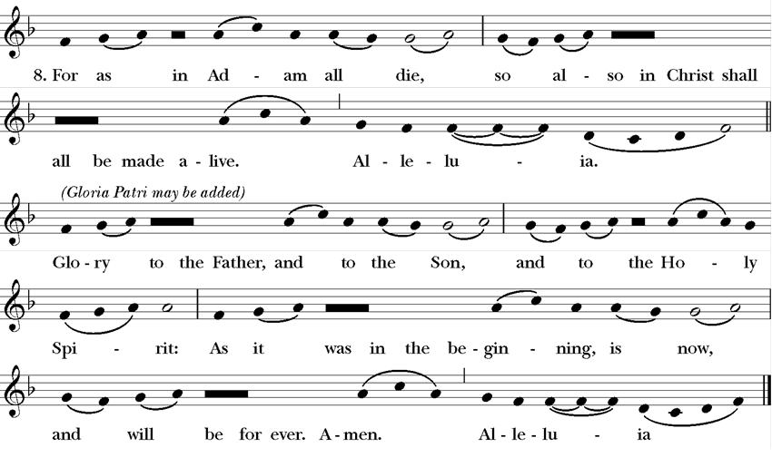

Psalm 63:1-8
p22EOW Deus, Deus meus

O God, you are my God; eagerly I seek you; *
my soul thirsts for you, my flesh faints for you,as in a barren and dry land where there is no water.
Therefore I have gazed upon you in your holy place, *
that I might behold your power and your glory.
For your loving-kindness is better than life itself; *
my lips shall give you praise.
So will I bless you as long as I live *
and lift up my hands in your Name.
My soul is content, as with marrow and fatness, *
and my mouth praises you with joyful lips,
When I remember you upon my bed, *
and meditate on you in the night watches.
For you have been my helper, *
and under the shadow of your wings I will rejoice.
My soul clings to you; *
your right hand holds me fast.

Psalm 67:1-5
p23EOW Deus misereatur

O God, be merciful to us and bless us, *
show us the light of your countenance and come to us.
Let your ways be known upon earth, *
your saving health among all nations.
Let the peoples praise you, O God; *
let all the peoples praise you.
Let the nations be glad and sing for joy, *
for you judge the peoples with equity and guide all the nations upon earth.
Let the peoples praise you, O God; *
let all the peoples praise you.

The Daily Psalter
Please Be Seated
The psalm assignments are found on p936-995 of the Book of Common Prayer [Holy Days p996-1001];
The Psalms are on pages 585-808of the BCP.

At the end of the Psalms is sung or said p84
Glory to the Father, and to the Son, and to the Holy Spirit: *
as it was in the beginning, is now, and will be for ever. Amen.

The Lessons and Canticles
The Lector Alone may stand for the reading
The Lectionary is found on pages p936-995[Holy Days p996-1001]
After the Lesson the Reader says:
The Word of the Lord OR Hear what the Spirit is saying to God’s people.
People: Thanks be to God.
A brief silence is kept after each Reading.

Canticles from the BCP (Are sung or said by all after each Reading. p47-53 & 85-96, and EOW)

8 The Song of Moses
All Standing, p85BCP Exodus 15:1-6, 11-13,17-18. Especially suitable for use in Easter Season
I will sing to the Lord, for he is lofty and uplifted; *
the horse and its rider has he hurled into the sea.
The Lord is my strength and my refuge; *
the Lord has become my Savior.
This is my God and I will praise him, *
the God of my people and I will exalt him.
The Lord is a mighty warrior; *
Yahweh is his Name.
The chariots of Pharaoh and his army has he hurled into the sea; *
the finest of those who bear armor have been
drowned in the Red Sea.
The fathomless deep has overwhelmed them; *
they sank into the depths like a stone.
Your right hand, O Lord, is glorious in might; *
your right hand, O Lord, has overthrown the enemy.
Who can be compared with you, O Lord, among the gods? *
who is like you, glorious in holiness,
awesome in renown, and worker of wonders?
You stretched forth your right hand; *
the earth swallowed them up.
With your constant love you led the people you redeemed; *
with your might you brought them in safety to
your holy dwelling.
You will bring them in and plant them *
on the mount of your possession,
The resting-place you have made for yourself, O Lord, *
the sanctuary, O Lord, that your hand has established.
The Lord shall reign *
for ever and for ever.
Glory to the Father, and to the Son, and to the Holy Spirit: *
as it was in the beginning, is now, and will be for ever. Amen.

9 The First Song of Isaiah
All Standing, p86BCP Isaiah 12:2-6
Surely, it is God who saves me; *
I will trust in him and not be afraid.
For the Lord is my stronghold and my sure defense, *
and he will be my Savior.
Therefore you shall draw water with rejoicing *
from the springs of salvation.
And on that day you shall say, *
Give thanks to the Lord and call upon his Name;
Make his deeds known among the peoples; *
see that they remember that his Name is exalted.
Sing the praises of the Lord, for he has done great things, *
and this is known in all the world.
Cry aloud, inhabitants of Zion, ring out your joy, *
for the great one in the midst of you is the Holy One of Israel.
Glory to the Father, and to the Son, and to the Holy Spirit: *
as it was in the beginning, is now, and will be for ever. Amen.
Or Chanted with Antiphon
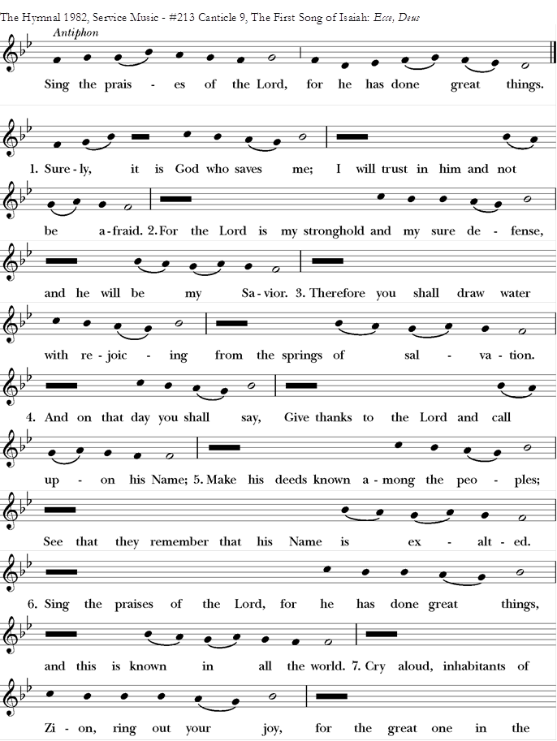
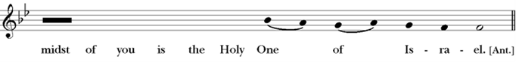
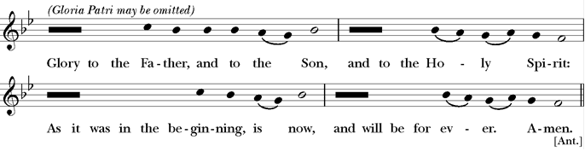

10 The Second Song of Isaiah
All Standing, p86BCP Isaiah 55:6-11
Seek the Lord while he wills to be found; *
call upon him when he draws near.
Let the wicked forsake their ways *
and the evil ones their thoughts;
And let them turn to the Lord, and he will have compassion, *
and to our God, for he will richly pardon.
For my thoughts are not your thoughts, *
nor your ways my ways, says the Lord.
For as the heavens are higher than the earth, *
so are my ways higher than your ways,
and my thoughts than your thoughts.
For as rain and snow fall from the heavens *
and return not again, but water the earth,
Bringing forth life and giving growth, *
seed for sowing and bread for eating,
So is my word that goes forth from my mouth; *
it will not return to me empty;
But it will accomplish that which I have purposed, *
and prosper in that for which I sent it.
Glory to the Father, and to the Son, and to the Holy Spirit: *
as it was in the beginning, is now, and will be for ever. Amen.
Or Chanted
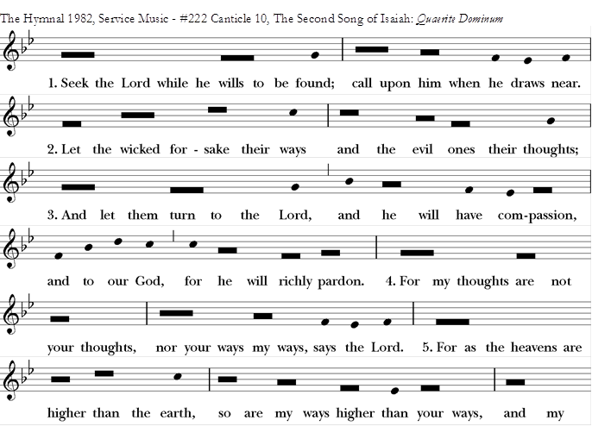
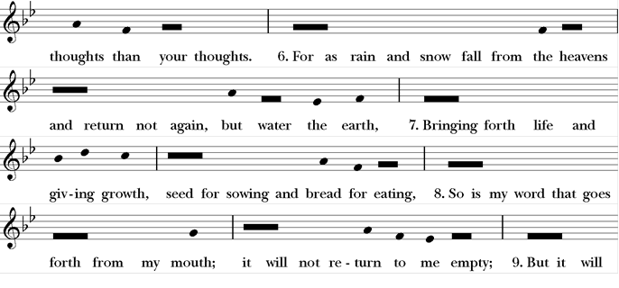
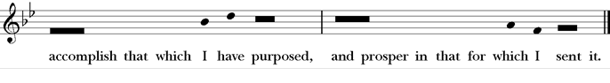

11 The Third Song of Isaiah
All Standing, p87BCP Isaiah60:1-3,11a,14c, 18-19

Arise, shine, for your light has come, *
and the glory of the Lord has dawned upon you.
For behold, darkness covers the land; *
deep gloom enshrouds the peoples.
But over you the Lord will rise, *
and his glory will appear upon you.
Nations will stream to your light, *
and kings to the brightness of your dawning.
Your gates will always be open; *
by day or night they will never be shut.
They will call you, The City of the Lord, *
The Zion of the Holy One of Israel.
Violence will no more be heard in your land, *
ruin or destruction within your borders.
You will call your walls, Salvation, *
and all your portals, Praise.
The sun will no more be your light by day; *
by night you will not need the brightness of the moon.
The Lord will be your everlasting light, *
and your God will be your glory.
Glory to the Father, and to the Son, and to the Holy Spirit: *
as it was in the beginning, is now, and will be for ever. Amen.
Or Chanted

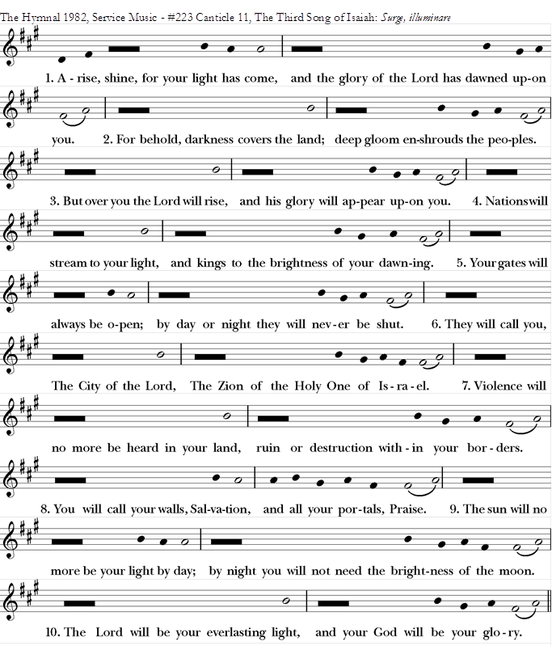
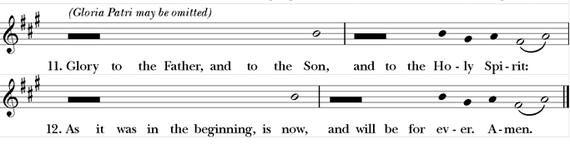

12 A Song of Creation
All Standing, p25EOW Song of the Three, 35–65
One or more sections of the Canticle may be used. However, the Canticle always begins with the Invocation and concludes with the Doxology.

Invocation
Glorify the Lord, all you works of the Lord, *
sing praise and give honor for ever.
In the high vault of heaven, glorify the Lord, *
sing praise and give honor for ever.

I. The Cosmic Order
Glorify the Lord, you angels and all powers of the Lord, *
O heavens and all waters above the heavens.
Sun and moon and stars of the sky, glorify the Lord, *
sing praise and give honor for ever.
Glorify the Lord, every shower of rain and fall of dew, *
all winds and fire and heat.
Winter and summer, glorify the Lord, *
sing praise and give honor for ever.
Glorify the Lord, O chill and cold, *
drops of dew and flakes of snow.
Frost and cold, ice and sleet, glorify the Lord, *
sing praise and give honor for ever.
Glorify the Lord, O nights and days, *
O shining light and enfolding dark.
Storm clouds and thunderbolts, glorify the Lord, *
sing praise and give honor for ever.

II. The Earth and Its Creatures
Let the earth glorify the Lord, *
sing praise and give honor for ever.
Glorify the Lord, O mountains and hills, and all that grows upon the earth, *
sing praise and give honor for ever.
Glorify the Lord, O springs of water, seas, and streams, *
O whales and all that move in the waters.
All birds of the air, glorify the Lord, *
sing praise and give honor for ever.
Glorify the Lord, O beasts of the wild, *
and all you flocks and herds.
O men and women everywhere, glorify the Lord, *
sing praise and give honor for ever.

III. The People of God
Let the people of God glorify the Lord, *
sing praise and give honor for ever.
Glorify the Lord, O priests and servants of the Lord, *
sing praise and give honor for ever.
Glorify the Lord, O spirits and souls of the righteous, *
sing praise and give honor for ever.
You that are holy and humble of heart, glorify the Lord, *
sing praise and give honor for ever.

Doxology
Let us glorify the Lord: Father, Son and Holy Spirit; *
sing praise and give honor for ever.
In the high vault of heaven, glorify the Lord, *
sing praise and give honor for ever.

13 A Song of Praise
All Standing, p90BCP Song of the Three Young Men, 29-34
Glory to you, Lord God of our forebears; *
you are worthy of praise; glory to you.
Glory to you for the radiance of your holy Name; *
we will praise you and highly exalt you for ever.
Glory to you in the splendor of your temple; *
on the throne of your majesty, glory to you.
Glory to you, seated between the Cherubim; *
we will praise you and highly exalt you for ever.
Glory to you, beholding the depths; *
in the high vault of heaven, glory to you.
Glory to you, Father, Son, and Holy Spirit; *
we will praise you and highly exalt you for ever.
Or Chanted

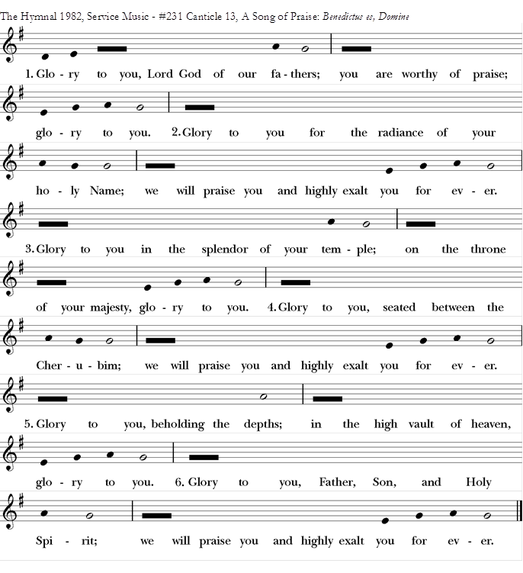

14 A Song of Penitence
All Standing, p90BCP Prayer of Manasseh1-2,4,6-7,11-15 Especially suitable in Lent, and on other penitential occasions

O Lord and Ruler of the hosts of heaven, *
God of Abraham, Isaac, and Jacob,
and of all their righteous offspring:
You made the heavens and the earth, *
with all their vast array.
All things quake with fear at your presence; *
they tremble because of your power.
But your merciful promise is beyond all measure; *
it surpasses all that our minds can fathom.
O Lord, you are full of compassion, *
long-suffering, and abounding in mercy.
You hold back your hand; *
you do not punish as we deserve.
In your great goodness, Lord,
you have promised forgiveness to sinners, *
that they may repent of their sin and be saved.
And now, O Lord, I bend the knee of my heart, *
and make my appeal, sure of your gracious goodness.
I have sinned, O Lord, I have sinned, *
and I know my wickedness only too well.
Therefore I make this prayer to you: *
Forgive me, Lord, forgive me.
Do not let me perish in my sin, *
nor condemn me to the depths of the earth.
For you, O Lord, are the God of those who repent, *
and in me you will show forth your goodness.
Unworthy as I am, you will save me,
in accordance with your great mercy, *
and I will praise you without ceasing all the days of my life.
For all the powers of heaven sing your praises, *
and yours is the glory to ages of ages. Amen.
Or Chanted with Antiphon
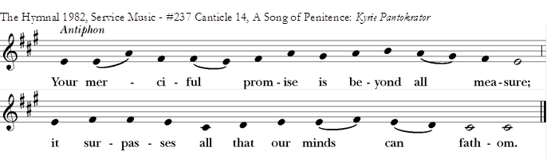
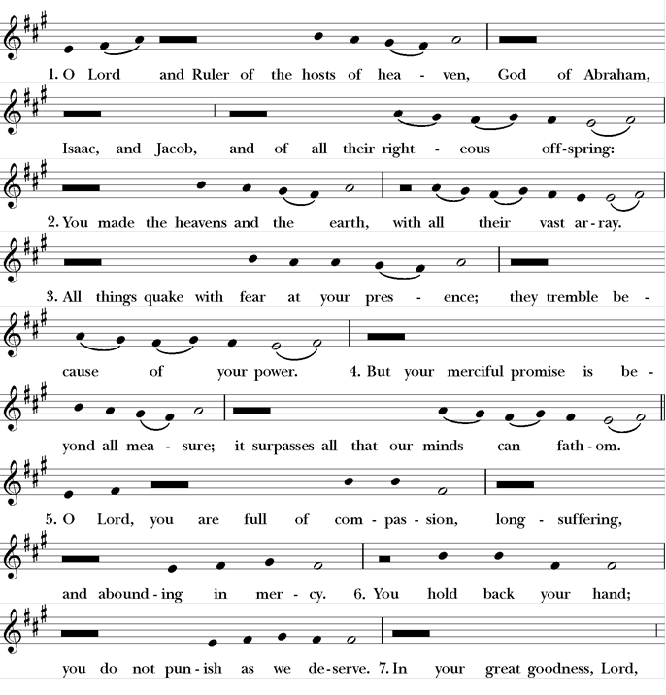
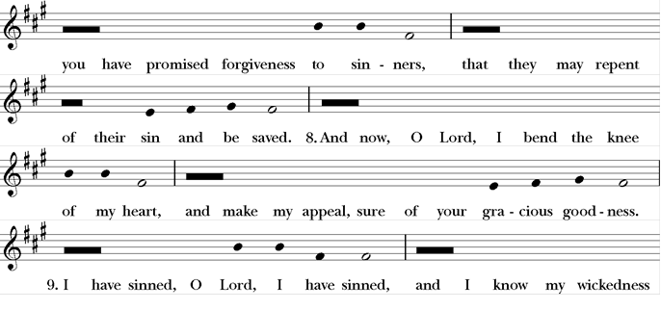
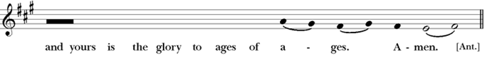

15 The Song of Mary
All Standing, p27EOW Luke 1:46-55

My soul proclaims the greatness of the Lord,
my spirit rejoices in you, O God my Savior, *
for you have looked with favor on your lowly servant.
From this day all generations will call me blessed: *
you, the Almighty, have done great things for me,
and holy is your name.
You have mercy on those who fear you *
from generation to generation.
You have shown strength with your arm *
and scattered the proud in their conceit,
Casting down the mighty from their thrones *
and lifting up the lowly.
You have filled the hungry with good things *
and sent the rich away empty.
You have come to the help of your servant Israel, *
for you have remembered your promise of mercy,
The promise made to our forebears, *
to Abraham and his children for ever.
Glory to the Father and to the Son and to the Holy Spirit *
As it was in the beginning, is now, and will be for ever. Amen.

Or Chanted with Antiphon
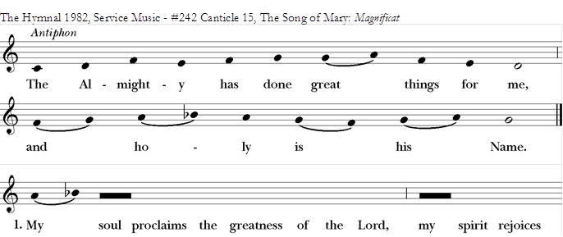
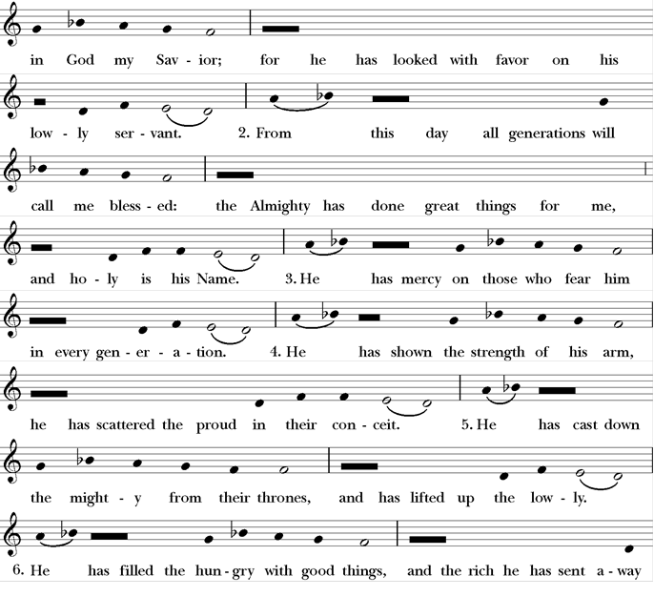
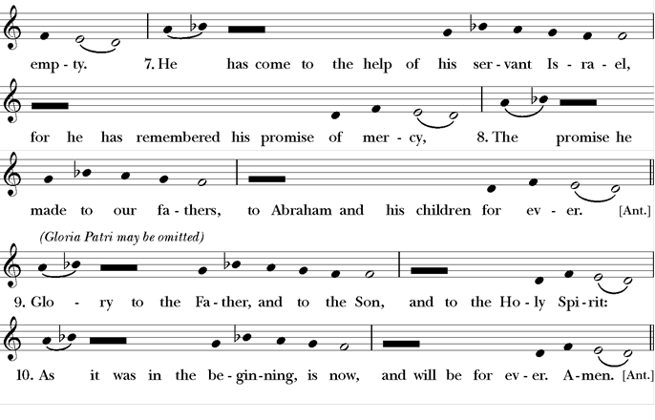

16 The Song of Zechariah
All Standing, p27EOW Luke 1: 68-79

Blessed are you, Lord, the God of Israel, *
you have come to your people and set them free.
You have raised up for us a mighty Savior, *
born of the house of your servant David.
Through your holy prophets you promised of old
to save us from our enemies, *
from the hands of all who hate us,
To show mercy to our forebears, *
and to remember your holy covenant.
This was the oath you swore to our father Abraham, *
to set us free from the hands of our enemies,
Free to worship you without fear, *
holy and righteous before you,all the days of our life.
And you, child, shall be called the prophetof the Most High, *
for you will go before the Lord to prepare the way,
To give God’s people knowledge of salvation *
by the forgiveness of their sins.
In the tender compassion of our God *
the dawn from on high shall break upon us,
To shine on those who dwell in darknessand the shadow of death, *
and to guide our feet into the way of peace.
Glory to the Father and to the Son and to the Holy Spirit *
As it was in the beginning, is now, and will be for ever. Amen.

Or Chanted with Antiphon

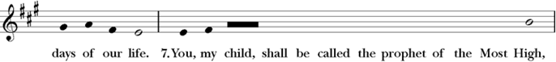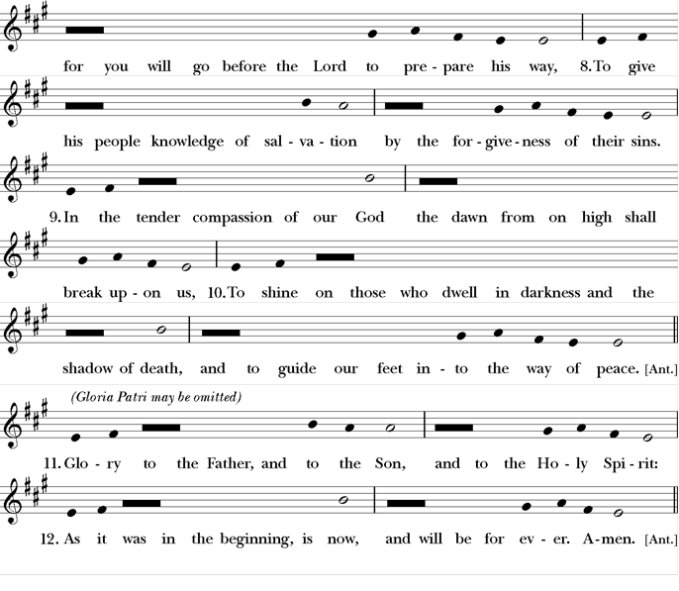

18 A Song to the Lamb
All Standing, p28EOW Revelation 4:11, 5:9-10, 13
Splendor and honor and royal power *
are yours by right, O God Most High,
For you created everything that is, *
and by your will they were created and have their being;
And yours by right, O Lamb that was slain, *
for with your blood you have redeemed for God,
From every family, language, people, and nation, *
a royal priesthood to serve our God.
And so, to the One who sits upon the throne, *
and to Christ the Lamb,
Be worship and praise, dominion and splendor, *
for ever and for evermore.
Or Chanted with Antiphon
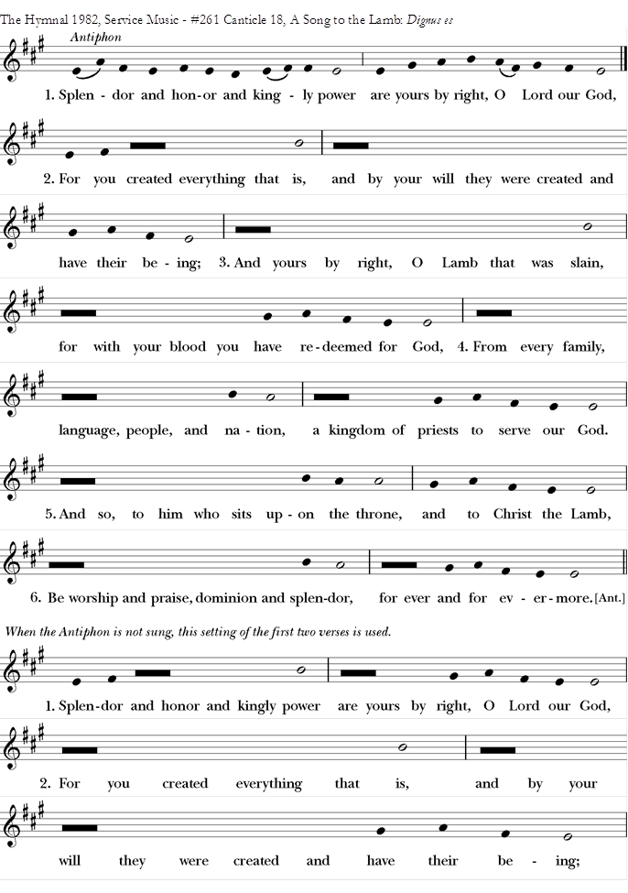

19 The Song of the Redeemed
All Standing, p94BCP Revelation 15:3-4
O ruler of the universe, Lord God,
great deeds are they that you have done, *
surpassing human understanding.
Your ways are ways of righteousness and truth, *
O King of all the ages.
Who can fail to do you homage, Lord,
and sing the praises of your Name? *
for you only are the Holy One.
All nations will draw near and fall down before you, *
because your just and holy works have been revealed.
Glory to the Father, and to the Son, and to the Holy Spirit: *
as it was in the beginning, is now, and will be for ever. Amen.
Or Chanted with Antiphon
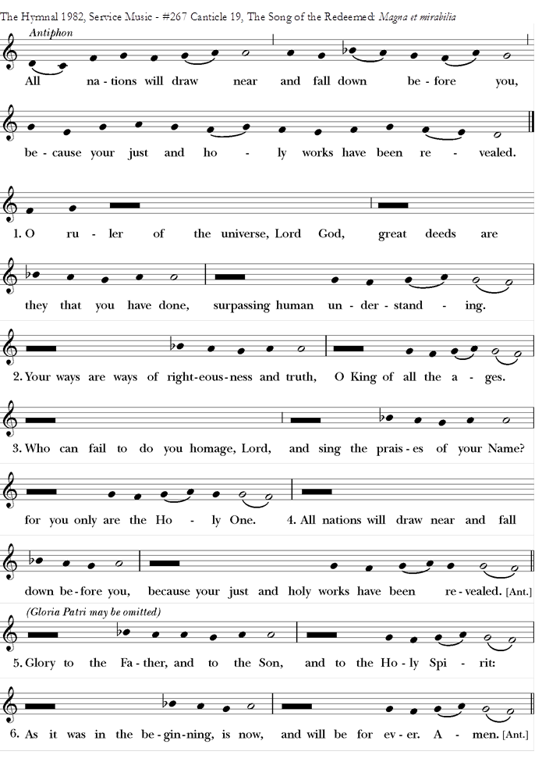

20 Glory to God
All Standing, p. 94 BCP
Glory to God in the highest,
and peace to his people on earth.
Lord God, heavenly King,
almighty God and Father,
we worship you, we give you thanks,
we praise you for your glory.
Lord Jesus Christ, only Son of the Father,
Lord God, Lamb of God,
you take away the sin of the world:
have mercy on us;
you are seated at the right hand of the Father:
receive our prayer.
For you alone are the Holy One,
you alone are the Lord,
you alone are the Most High,
Jesus Christ,
with the Holy Spirit,
in the glory of God the Father. Amen.

21 You are God
All Standing, p29EOW Te Deum laudamus

We praise you, O God,
we acclaim you as Lord;
all creation worships you,
the Father everlasting.
To you all angels, all the powers of heaven,
the cherubim and seraphim, sing in endless praise:
Holy, holy, holy Lord, God of power and might,
heaven and earth are full of your glory.
The glorious company of apostles praise you.
The noble fellowship of prophets praise you.
The white-robed army of martyrs praise you.
Throughout the world the holy Church acclaims you:
Father, of majesty unbounded,
your true and only Son, worthy of all worship, and the Holy Spirit,
advocate and guide.
You, Christ, are the king of glory,
the eternal Son of the Father.
When you took our flesh to set us free
you humbly chose the Virgin’s womb.
You overcame the sting of death
and opened the kingdom of heaven to all believers.
You are seated at God’s right hand in glory.
We believe that you will come to be our judge.
Come then, Lord, and help your people,
bought with the price of your own blood,
and bring us with your saints
to glory everlasting.

Canticles from Enriching Our Worship

B - A Song of Pilgrimage
All Standing, p30EOW Ecclesiasticus 51:13-16,20b-22
Before I ventured forth, even while I was very young, *
I sought wisdom openly in my prayer.
In the forecourts of the temple I asked for her, *
and I will seek her to the end.
From first blossom to early fruit, *
she has been the delight of my heart.
My foot has kept firmly to the true path, *
diligently from my youth have I pursued her.
I inclined my ear a little and received her; *
I found for myself much wisdom and became adept in her.
To the one who gives me wisdom will I give glory, *
for I have resolved to live according to her way.
From the beginning I gained courage from her, *
therefore I will not be forsaken.
In my inmost being I have been stirred to seek her, *
therefore have I gained a good possession.
As my reward the Almighty has given me the gift of language,*
and with it will I offer praise to God.

Canticle D - A Song of the Wilderness
All Standing, p32EOW Isaiah 35:1-7,10
The wilderness and the dry land shall be glad, *
the desert shall rejoice and blossom;
It shall blossom abundantly, *
and rejoice with joy and singing.
They shall see the glory of the Lord, *
the majesty of our God.
Strengthen the weary hands, *
and make firm the feeble knees.
Say to the anxious, “Be strong, do not fear! *
Here is your God, coming with judgment to save you.”
Then shall the eyes of the blind be opened, *
and the ears of the deaf be unstopped.
Then shall the lame leap like a deer, *
and the tongue of the speechless sing for joy.
For waters shall break forth in the wilderness *
and streams in the desert;
The burning sand shall become a pool *
and the thirsty ground, springs of water.
The ransomed of God shall return with singing, *
with everlasting joy upon their heads.
Joy and gladness shall be theirs, *
and sorrow and sighing shall flee away.

Canticle E - A Song of Jerusalem Our Mother
All Standing, p32 EOW Isaiah 66:10-14
Rejoice with Jerusalem and be glad for her *
all you who love her,
Rejoice, rejoice with her, *
all you who mourn over her,
That you may drink deeply with delight *
from her comforting breast.
For thus says our God, *
“I will extend peace to her like a river,
the wealth of nations like an overflowing stream.
“You shall nurse and be carried on her arm, *
and you shall nestle in her lap.
“As a mother comforts her child, so will I comfort you; *
you shall be comforted in Jerusalem.
“You shall see, and your heart shall rejoice, *
you shall flourish like the grass of the fields.”

Canticle F - A Song of Lamentation
All Standing, p33EOW Lamentations 1:12,16; 3:19,22-24,26
Is it nothing to you, all you who pass by? *
Look and see if there is any sorrow like my sorrow,
Which was brought upon me, *
inflicted by God’s fierce anger.
For these things I weep; my eyes flow with tears, *
for a comforter is far from me, one to revive my courage.
Remember my affliction and my bitterness, *
wormwood and gall!
The steadfast love of God never ceases, *
God’s mercies never end.
They are new every morning; *
great is your faithfulness.
“God is my portion,” says my soul, *
“therefore will I hope in God.”
It is good that we should wait quietly *
for the coming of God’s salvation.

Canticle G - A Song of Ezekiel
All Standing, p34EOW Ezekiel 36:24-28
I will take you from among all nations; *
and gather you from all lands to bring you home.
I will sprinkle clean water upon you; *
and purify you from false gods and uncleanness.
A new heart I will give you *
and a new spirit put within you.
I will take the stone heart from your chest *
and give you a heart of flesh.
I will help you walk in my laws *
and cherish my commandments and do them.
You shall be my people, *
and I will be your God.

Canticle J - A Song of Judith
All Standing, p35EOW Judith 16:13-16
I will sing a new song to my God, *
for you are great and glorious, wonderful in strength, invincible.
Let the whole creation serve you, *
for you spoke and all things came into being.
You sent your breath and it formed them, *
no one is able to resist your voice.
Mountains and seas are stirred to their depths, *
rocks melt like wax at your presence.
But to those who fear you, *
you continue to show mercy.
No sacrifice, however fragrant, can please you, *
but whoever fears the Lord shall stand in your sight for ever.

Canticle L - A Song of Christ’s Humility
All Standing, p36EOW Philippians 2:6-11
Though in the form of God, *
Christ Jesus did not cling to equality with God,
But emptied himself, taking the form of a servant, *
and was born in human likeness.
Being found in human form, he humbled himself *
and became obedient to death, even death on a cross.
Therefore, God has highly exalted him *
and given him the name above every name,
That at the name of Jesus, every knee shall bow, *
in heaven and on earth and under the earth,
And every tongue confess that Jesus Christ is Lord, *
to the glory of God the Father.

Canticle M - A Song of Faith
All Standing p37EOW 1 Peter 1:3-4,18-21
Blessed be the God and Father of our Lord Jesus Christ, *
by divine mercy we have a new birth into a living hope;
Through the resurrection of Jesus Christ from the dead, *
we have an inheritance that is imperishable in heaven.
The ransom that was paid to free us *
was not paid in silver or gold,
But in the precious blood of Christ, *
the Lamb without spot or stain.
God raised Jesus from the dead and gave him glory *
so that we might have faith and hope in God.

Canticle N - A Song of God’s Love
All Standing p37EOW 1 John 4:7-11
Beloved, let us love one another, *
for love is of God.
Whoever does not love does not know God, *
for God is Love.
In this the love of God was revealed among us, *
that God sent his only Son into the world,
so that we might live through Jesus Christ.
In this is love, not that we loved God but that God loved us *
and sent his Son that sins might be forgiven.
Beloved, since God loved us so much, *
we ought also to love one another.
For if we love one another, God abides in us, *
and God’s love will be perfected in us.

Canticle Q – A Song of Christ’s Goodness
p 39, EOW Anselm of Canterbury
Jesus, as a mother you gather your people to you; *
you are gentle with us as a mother with her children.
Often you weep over our sins and our pride, *
tenderly you draw us from hatred and judgment.
You comfort us in sorrow and bind up our wounds, *
in sickness you nurse us and with pure milk you feed us.
Jesus, by your dying, we are born to new life; *
by your anguish and labor we come forth in joy.
Despair turns to hope through your sweet goodness; *
through your gentleness, we find comfort in fear.
Your warmth gives life to the dead, *
your touch makes sinners righteous.
Lord Jesus, in your mercy, heal us; *
in your love and tenderness, remake us.
In your compassion, bring grace and forgiveness, *
for the beauty of heaven, may your love prepare us.

The Apostles' Creed
All Standing BCP p96
I believe in God, the Father almighty,
creator of heaven and earth;
I believe in Jesus Christ, his only Son, our Lord.
He was conceived by the power of the Holy Spirit
and born of the Virgin Mary.
He suffered under Pontius Pilate,
was crucified, died, and was buried.
He descended to the dead.
On the third day he rose again.
He ascended into heaven,
and is seated at the right hand of the Father.
He will come again to judge the living and the dead.
I believe in the Holy Spirit,
the holy catholic Church,
the communion of saints,
the forgiveness of sins
the resurrection of the body,
and the life everlasting. Amen.

The Prayers

Standing or Kneeling p97BCP
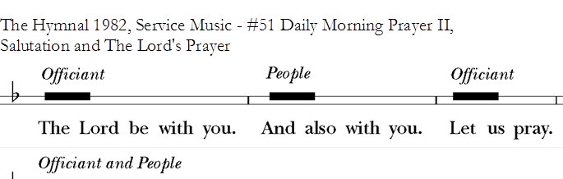
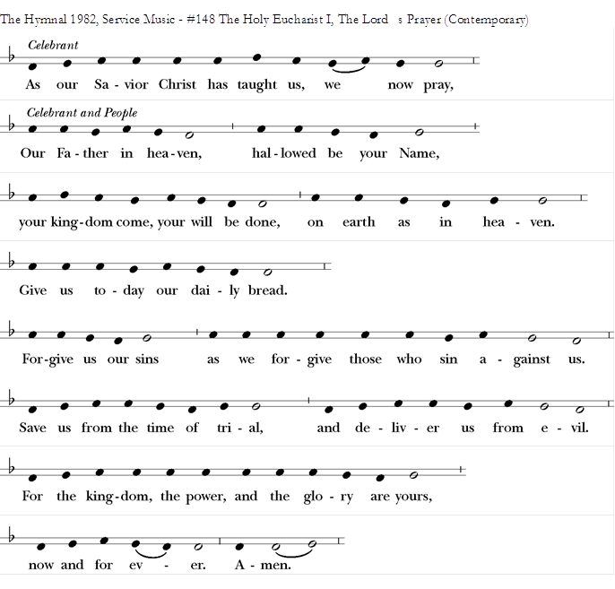

Or this
Our Father, who art in heaven,
hallowed be thy Name,
thy kingdom come,
thy will be done,
on earth as it is in heaven.
Give us this day our daily bread.
And forgive us our trespasses,
as we forgive those who trespass against us.
And lead us not into temptation, but deliver us from evil.
For thine is the kingdom,
and the power, and the glory,
for ever and ever. Amen.
Suffrages

Suffrages A
p97BCP May be said or sung
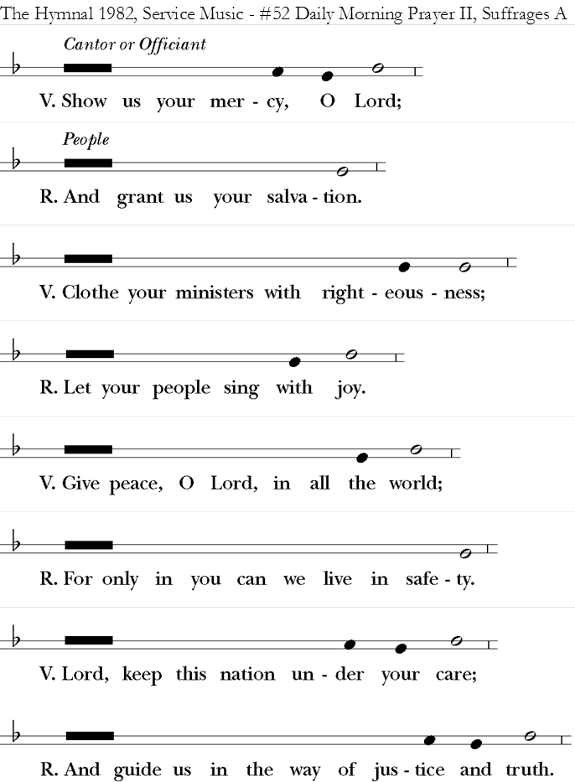

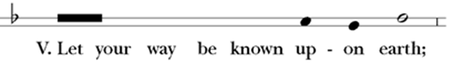
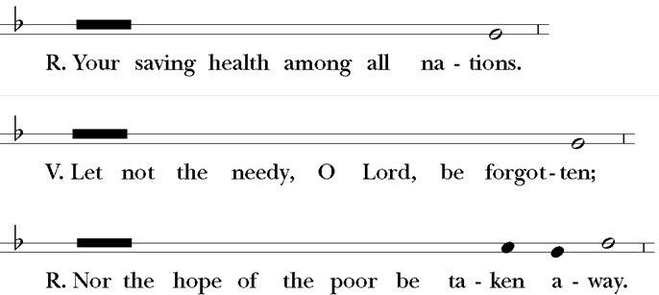
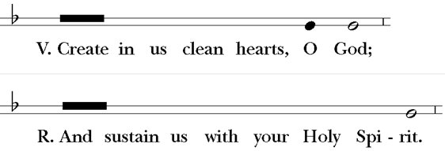

Suffrages B
May be sung or said
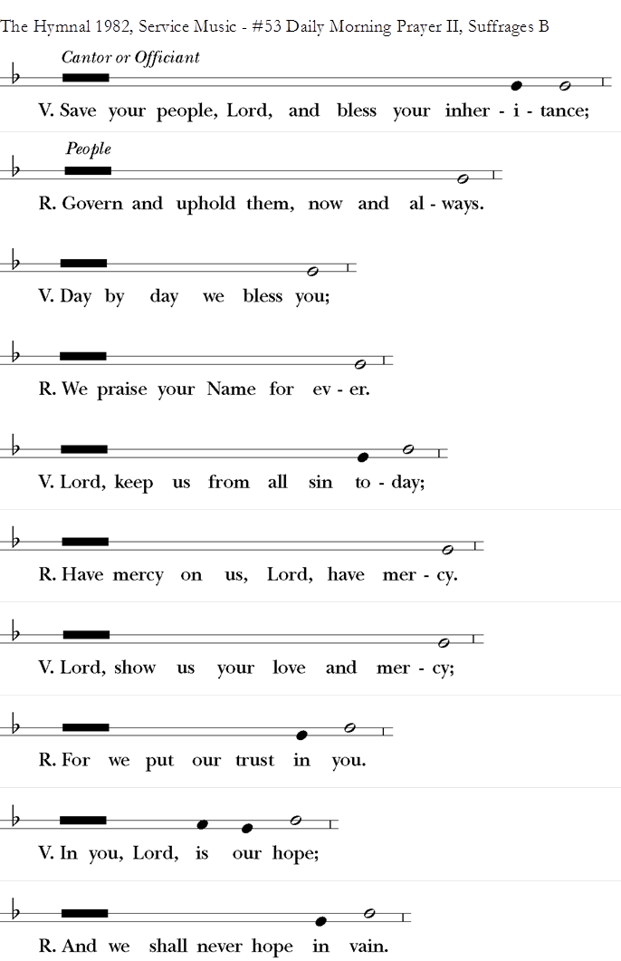

Suffrages C
(Enriching Our Worship, p 42)
V. Help us, O God our Savior;
R. Deliver us and forgive us our sins.
V. Look upon your congregation;
R. Give to your people the blessing of peace.
V. Declare your glory among the nations;
R. And your wonders among all peoples.
V. Do not let the oppressed be shamed and turned away;
R. Never forget the lives of your poor.
V. Continue your loving-kindness to those who know you;
R. And your favor to those who are true of heart.
V. Satisfy us by your loving-kindness in the morning;
R. So shall we rejoice and be glad all the days of our life.

The Collects
p98-100BCP

The Collect of the Day
(found on BCP p211-250), please always say this

A second Collect from below
with the daily guidance as suggestions only (Additional Collects for sections II and III may be found on BCP, pages 251-261)

A Collect for Sundays
O God, you make us glad with the weekly remembrance of the glorious resurrection of your Son our Lord: Give us this day such blessing through our worship of you, that the week to come may be spent in your favor; through Jesus Christ our Lord. Amen.

A Collect for Fridays
Almighty God, whose most dear Son went not up to joy but first he suffered pain, and entered not into glory before he was crucified: Mercifully grant that we, walking in the way of the cross, may find it none other than the way of life and peace; through Jesus Christ our Lord. Amen.

A Collect for Saturdays
Almighty God, who after the creation of the world rested from all your works and sanctified a day of rest for all your creatures: Grant that we, putting away all earthly anxieties, may be duly prepared for the service of your sanctuary, and that our rest here upon earth may be a preparation for the eternal rest promised to your people in heaven; through Jesus Christ our Lord. Amen.
A Collect for the Renewal of Life (Monday)
O God, the King eternal, whose light divides the day from the night and turns the shadow of death into the morning: Drive far from us all wrong desires, incline our hearts to keep your law, and guide our feet into the way of peace; that, having done your will with cheerfulness while it was day, we may, when night comes, rejoice to give you thanks; through Jesus Christ our Lord. Amen.
A Collect for Peace (Tuesday)
O God, the author of peace and lover of concord, to know you is eternal life and to serve you is perfect freedom: Defend us, your humble servants, in all assaults of our enemies; that we, surely trusting in your defense, may not fear the power of any adversaries; through the might of Jesus Christ our Lord. Amen.

A Collect for Grace (Wednesday)
Lord God, almighty and everlasting Father, you have brought us in safety to this new day: Preserve us with your mighty power, that we may not fall into sin, nor be overcome by adversity; and in all we do, direct us to the fulfilling of your purpose; through Jesus Christ our Lord. Amen.
A Collect for Guidance (Thursday)
Heavenly Father, in you we live and move and have our being: We humbly pray you so to guide and govern us by your Holy Spirit, that in all the cares and occupations of our life we may not forget you, but may remember that we are ever walking in your sight; through Jesus Christ our Lord. Amen.

Collects for Mission
p100-101 or from pages 251-261 as above.
Almighty and everlasting God, by whose Spirit the whole body of your faithful people is governed and sanctified: Receive our supplications and prayers which we offer before you for all members of your holy Church, that in their vocation and ministry they may truly and devoutly serve you; through our Lord and Savior Jesus Christ. Amen.

or this
O God, you have made of one blood all the peoples of the earth, and sent your blessed Son to preach peace to those who are far off and to those who are near: Grant that people everywhere may seek after you and find you; bring the nations into your fold; pour out your Spirit upon all flesh; and hasten the coming of your kingdom; through Jesus
Christ our Lord. Amen.
or the following
Lord Jesus Christ, you stretched out your arms of love on the hard wood of the cross that everyone might come within the reach of your saving embrace: So clothe us in your Spirit that we, reaching forth our hands in love, may bring those who do not know you to the knowledge and love of you; for the honor of your Name. Amen.

Authorized intercessions and thanksgivings may follow p814-841 (please note these are not collects and should not be used in the section above.) Free petitions from community may also be offered.

Here may be sung a hymn or anthem.

Concluding Prayers
Standing

The General Thanksgiving
p101or what follows

Almighty God, Father of all mercies,
we your unworthy servants give you humble thanks
for all your goodness and loving-kindness
to us and to all whom you have made.
We bless you for our creation, preservation,
and all the blessings of this life;
but above all for your immeasurable love
in the redemption of the world by our Lord Jesus Christ;
for the means of grace, and for the hope of glory.
And, we pray, give us such an awareness of your mercies,
that with truly thankful hearts we may show forth your praise,
not only with our lips, but in our lives,
by giving up ourselves to your service,
and by walking before you in holiness and righteousness all our days;
through Jesus Christ our Lord,
to whom, with you and the Holy Spirit,
be honor and glory throughout all ages. Amen.

Or

An Alternate Thanksgiving
BCP p836
Accept, O Lord, our thanks and praise for all that you have done for us. We thank you for the splendor of the whole creation, for the beauty of this world, for the wonder of life, and for the mystery of love.
We thank you for the blessing of family and friends, and for the loving care which surrounds us on every side.
We thank you for setting us at tasks which demand our best efforts, and for leading us to accomplishments which satisfy and delight us.
We thank you also for those disappointments and failures that lead us to acknowledge our dependence on you alone.
Above all, we thank you for your Son Jesus Christ; for the truth of his Word and the example of his life; for his steadfast obedience, by which he overcame temptation; for his dying, through which he overcame death; and for his rising to life again, in which we are raised to the life of your kingdom.
Grant us the gift of your Spirit, that we may know him and make him known; and through him, at all times and in all places, may give thanks to you in all things. Amen.
Or

A Prayer of St. Chrysostom
BCP p102
Almighty God, you have given us grace at this time with one accord to make our common supplication to you; and you have promised through your well-beloved Son that when two or three are gathered together in his Name you will be in the midst of them: Fulfill now, O Lord, our desires and petitions as may be best for us; granting us in this world knowledge of your truth, and in the age to come life everlasting. Amen.

Concluding Versicle and Response
The Hymnal 1982, S54

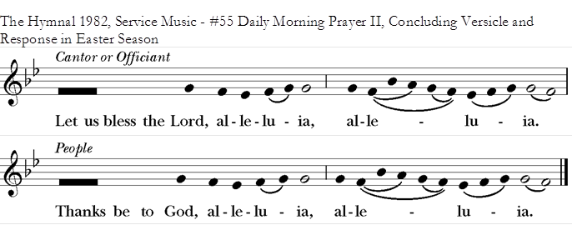

Dismissal
BCP, p102
The grace of our Lord Jesus Christ, and the love of God, and the fellowship of the Holy Spirit, be with us all evermore. Amen.
2 Corinthians 13:14

May the God of hope fill us with all joy and peace in believing through the power of the Holy Spirit. Amen.
Romans 15:13

Glory to God whose power, working in us, can do infinitely more than we can ask or imagine: Glory to him from generation to generation in the Church, and in Christ Jesus for ever and ever. Amen.
Ephesians 3:20,21

